

Cloud Computing Lab

Submitted To:

Sir Waqas & Sir Shoaib

Submitted By:

Hamail Fatima

Roll No:

2023-BSE-023

Section:

5(A)

Task 0 Lab Setup (Codespace & GH CLI)

All actions below should be executed inside the Codespace shell.
Create Codespace & connect:

# create or open codespace via GH CLI (example)

gh repo create CC_<YourName>_<YourRollNumber>/Lab11 --public
gh codespace create --repo <user_name>/Lab11
gh codespace list
gh codespace ssh -c <your_codespace_name>

- Save screenshot as: taskA_codespace_create_and_list.png — output showing repo creation/codespace list.
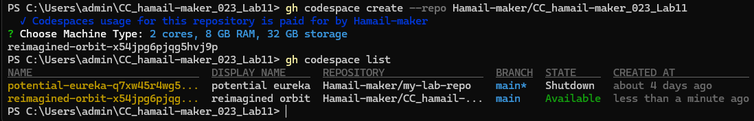

- Save screenshot as: taskA_codespace_ssh_connected.png — terminal inside the Codespace shell after ssh.

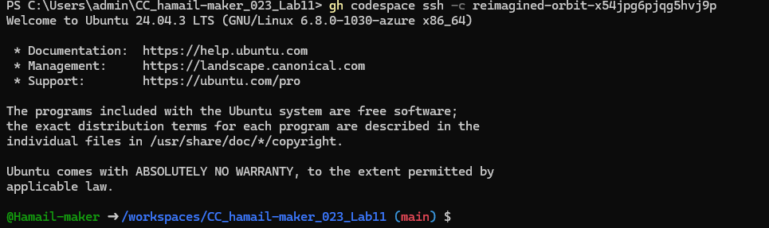

Task 1 — Provider & Basic variable (variable precedence)
- In Codespace create main.tf:
touch main.tf
- Save screenshot as: task1_touch_main_tf.png — terminal showing touch main.tf.
- Edit main.tf and add provider:
provider "aws" {
shared_config_files = ["~/.aws/config"]
shared_credentials_files = ["~/.aws/credentials"]
}
- Save screenshot as: task1_main_tf_provider.png — editor showing provider block saved in main.tf.

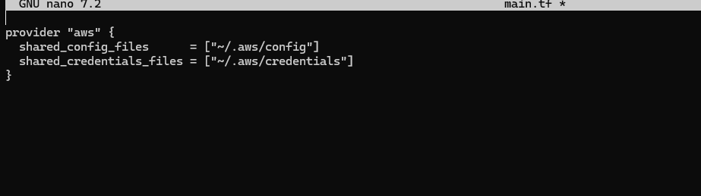
- Initialize:
terraform init
- Save screenshot as: task1_terraform_init.png — terraform init output.
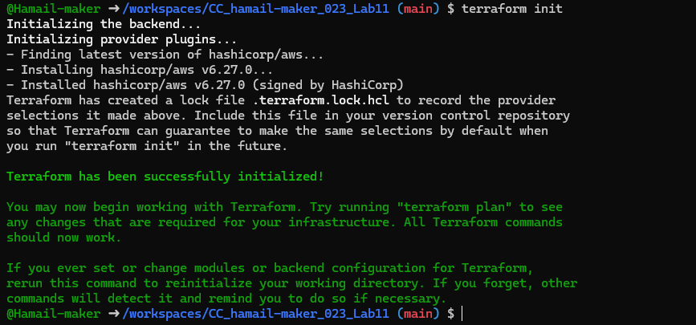
- Define a variable and output:
variable "subnet_cidr_block" {
type = string
}

output "subnet_cidr_block_output" {
value = var.subnet_cidr_block
}
- Save screenshot as: task1_variable_and_output_added.png — main.tf showing variable and output blocks.
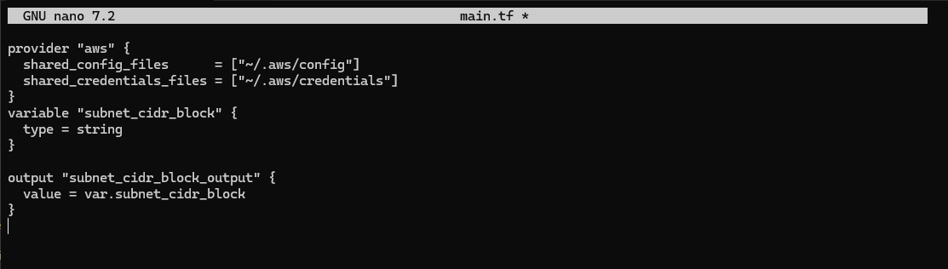
- Run apply (first time without defaults):
terraform apply -auto-approve
# it will prompt for the value of subnet_cidr_block
- Save screenshot as: task1_apply_prompt_for_var.png — terminal showing terraform prompting for variable input.
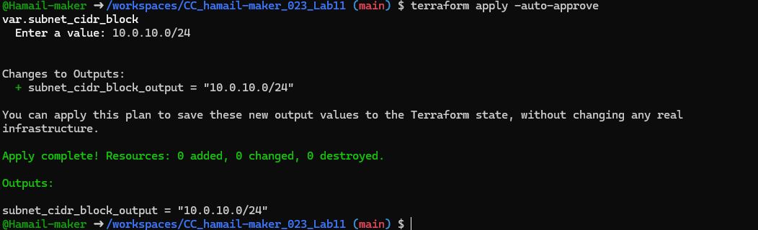
- Add a default to the variable:
variable "subnet_cidr_block" {
type = string
default = "10.0.0.0/24"
}
Run:
terraform apply -auto-approve
# will use default without prompting
- Save screenshot as: task1_apply_with_default.png — apply output showing default used.
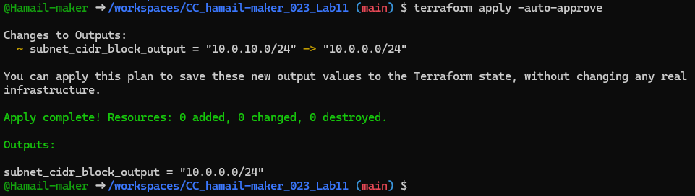
- Export environment variable in Codespace shell:
export TF_VAR_subnet_cidr_block=10.0.20.0/24
terraform apply -auto-approve
# output should show environment value
- Save screenshot as: task1_env_var_set_and_apply.png — terminal showing export and apply using TF_VAR value.
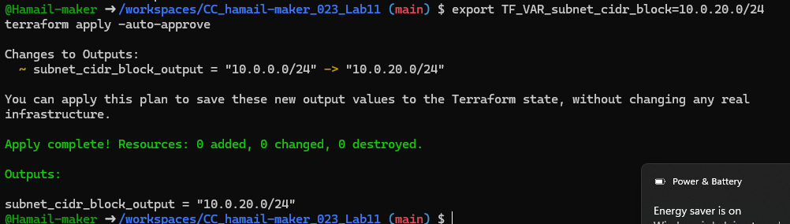
- Create terraform.tfvars overriding values:
touch terraform.tfvars
# inside terraform.tfvars:
subnet_cidr_block = "10.0.30.0/24"
terraform apply -auto-approve
# terraform.tfvars has priority over default and env
- Save screenshot as: task1_terraform_tfvars_and_apply.png — cat terraform.tfvars and apply output showing its value used.
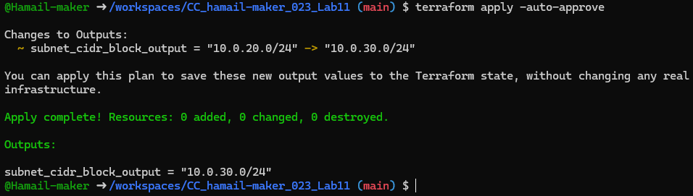
- Override with -var:
terraform apply -auto-approve -var "subnet_cidr_block=10.0.40.0/24"
# -var is highest precedence
- Save screenshot as: task1_var_override_with_dash_var.png — command and apply showing -var value used.
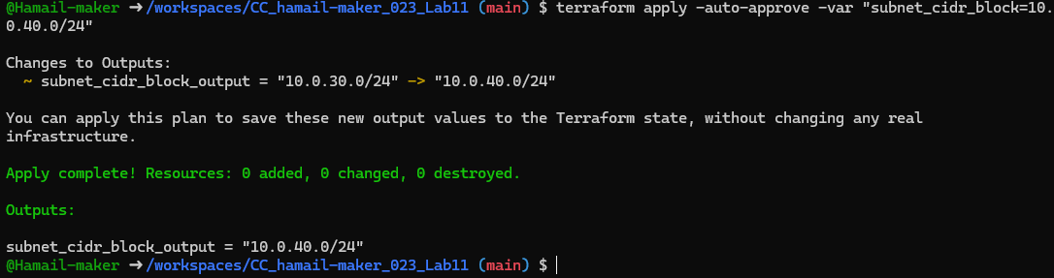
- Show and unset env var:
printenv | grep TF_VAR_
unset TF_VAR_subnet_cidr_block
printenv | grep TF_VAR_
- Save screenshot as: task1_printenv_tf_var_and_unset.png — showing TF_VAR present and then removed.
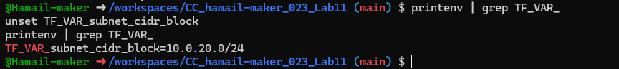

Task 2 — Variable validation & sensitive / ephemeral variables
- Replace subnet_cidr_block variable with this (validation included):
variable "subnet_cidr_block" {
type = string
default = ""
description = "CIDR block to assign to the application subnet"
sensitive = false
nullable = false
ephemeral = false

validation {
condition = can(regex("^([0-9]{1,3}\\.){3}[0-9]{1,3}/[0-9]+$", var.subnet_cidr_block))
error_message = "The subnet_cidr_block must be a valid CIDR notation string, such as 10.0.0.0/24."
}
}
- Save screenshot as: task2_subnet_variable_with_validation.png — main.tf showing
validation block.
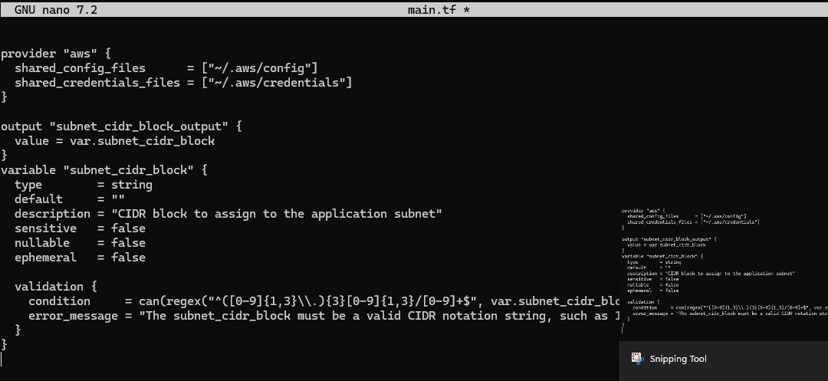
- Test validation failure:
terraform apply -auto-approve -var "subnet_cidr_block=10.0.0"
# should show validation error
- Save screenshot as: task2_subnet_validation_error.png — terminal showing validation error message.
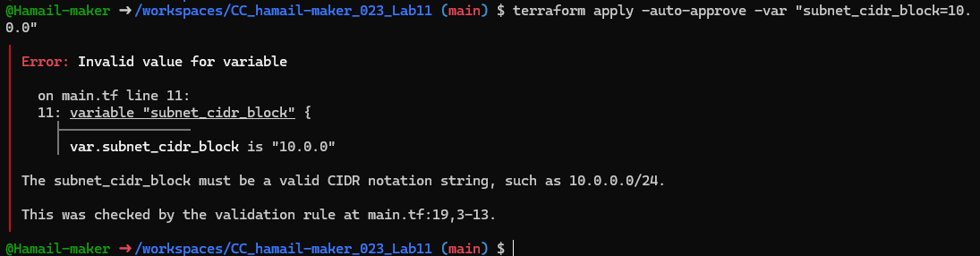
- Create a sensitive variable api_session_token and output (sensitive):
variable "api_session_token" {
type = string
default = ""
description = "Short-lived API session token used during apply operations"
sensitive = true
nullable = false
ephemeral = false

validation {
condition = can(regex("^[A-Za-z0-9-_]{20,}$", var.api_session_token))
error_message = "The API session token must be at least 20 characters and contain only letters, numbers, hyphens, or underscores."
}
}

output "api_session_token_output" {
value = var.api_session_token
sensitive = true
}
- Save screenshot as: task2_api_token_variable_added.png — main.tf showing api_session_token and sensitive output.
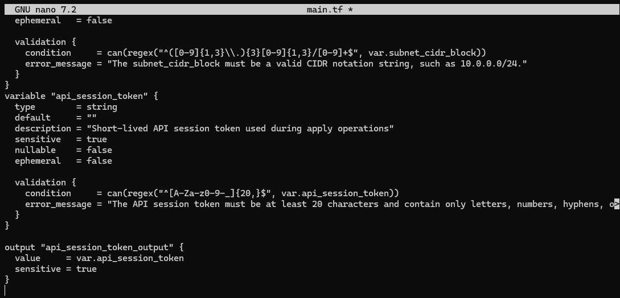
- Run with -var to observe sensitive output behavior:
terraform apply -auto-approve -var "api_session_token=my_API_session_Token"
# output will be marked sensitive; check terraform.tfstate for outputs
- Save screenshot as: task2_api_token_apply_sensitive.png — apply output showing sensitive output masked and/or noted.
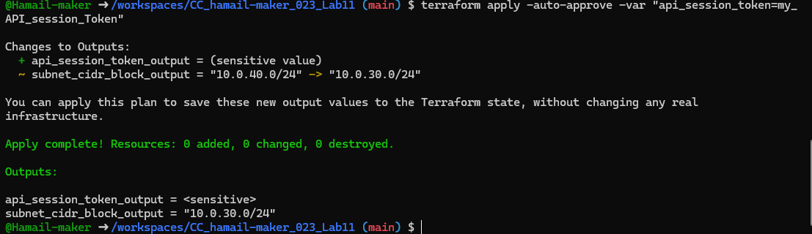
- Check terraform.state for the sensitive output:
- You should find an outputs section similar to:
"api_session_token_output": {
"value": "my_API_session_Token",
"type": "string",
"sensitive": true
}
- Save screenshot as: task2_check_terraform_state_api_token.png — showing terraform.tfstate outputs containing "api_session_token_output" with sensitive = true.
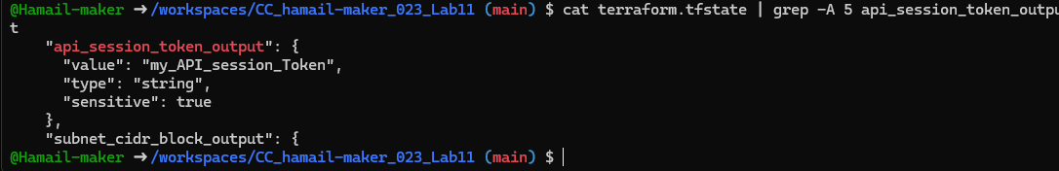
- Make variable ephemeral to hide from state:
variable "api_session_token" {
...
ephemeral = true
...
}
- Save screenshot as: task2_api_token_ephemeral_error.png — terminal showing error or behavior when trying to output ephemeral variable.
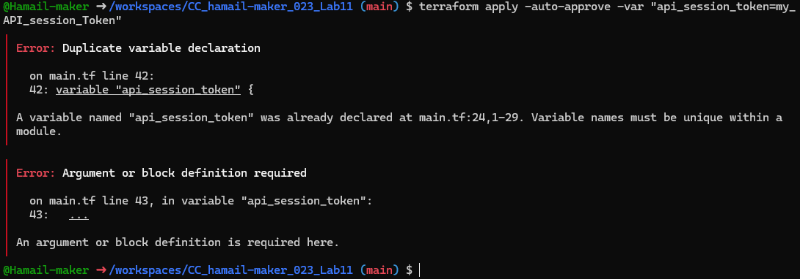
- Set default to test local default:
variable "api_session_token" {
default = "my_API_session_Token"
sensitive = true
ephemeral = false
...
}
terraform apply -auto-approve
# works and stored in state (but output remains sensitive)
- Save screenshot as: task2_api_token_default_apply.png — apply output showing default sensitive value accepted.
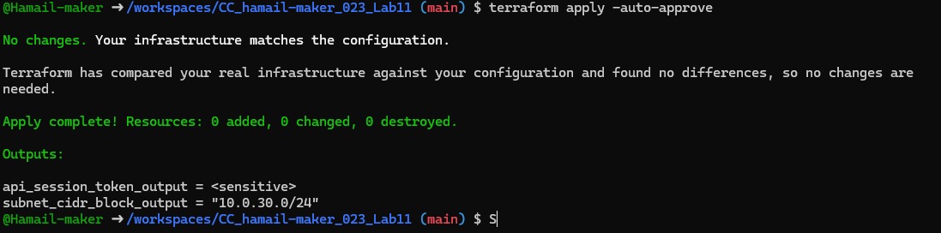

Task 3 — Project-level variables, locals, and outputs
- Add variables to main.tf:
variable "environment" {}
variable "project_name" {}
variable "primary_subnet_id" {}
variable "subnet_count" {}
variable "monitoring" {}
- Save screenshot as: task3_variables_added.png — main.tf showing new variables.
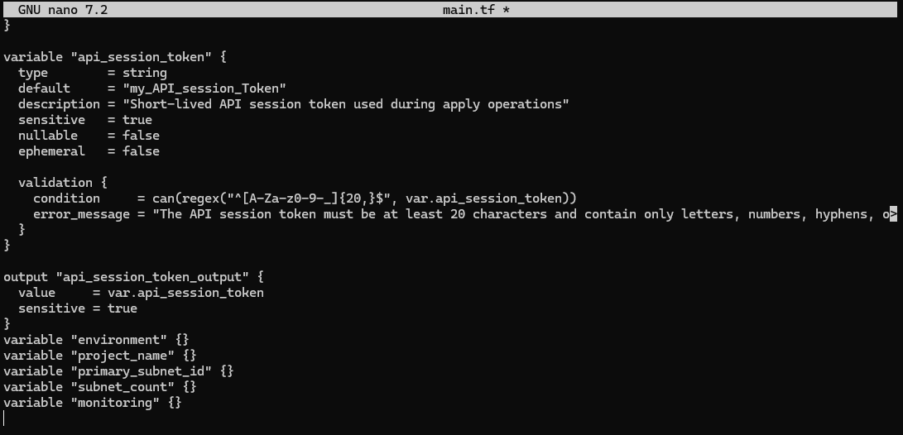
- Populate terraform.tfvars after discovering actual subnet id for availability zone me-central-1a:
aws ec2 describe-subnets \
--filters "Name=availability-zone,Values=me-central-1a" \
--query "Subnets[].SubnetId" \
--output text
Set values in terraform.tfvars:
environment = "dev"
project_name = "lab_work"
primary_subnet_id = "<subnet-id-of-me-central-1a>"
subnet_count = 3
monitoring = true
- Save screenshot as: task3_terraform_tfvars_populated.png — terraform.tfvars content and aws describe-subnets output showing subnet id.
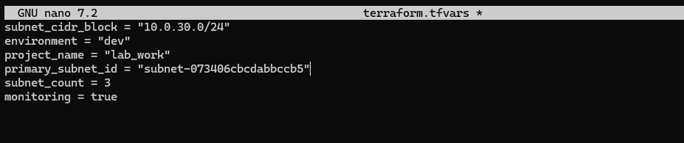
- Create locals.tf with:
locals {
resource_name = "${var.project_name}-${var.environment}"
primary_public_subnet = var.primary_subnet_id
subnet_count = var.subnet_count
is_production = var.environment == "prod"
monitoring_enabled = var.monitoring || local.is_production
}
- Save screenshot as: task3_locals_tf_created.png — locals.tf content saved.
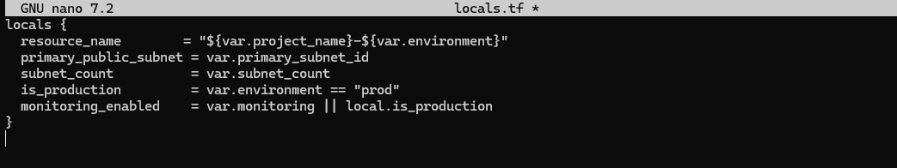
- Add outputs to main.tf:
output "resource_name" {
value = local.resource_name
}
output "primary_public_subnet" {
value = local.primary_public_subnet
}
output "subnet_count" {
value = local.subnet_count
}
output "is_production" {
value = local.is_production
}
output "monitoring_enabled" {
value = local.monitoring_enabled
}
- Run:
terraform apply -auto-approve
# will show all the output values
- Save screenshot as: task3_outputs_apply.png — terraform apply output showing these outputs.
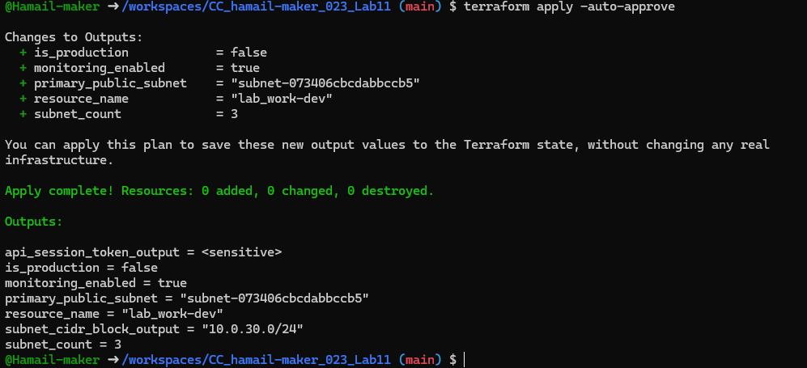

Task 4 — Maps and Objects
- Map variable in main.tf:
variable "tags" {
type = map(string)
}

output "tags" {
value = var.tags
}
- Save screenshot as: task4_tags_variable_added.png — main.tf showing tags variable and output.
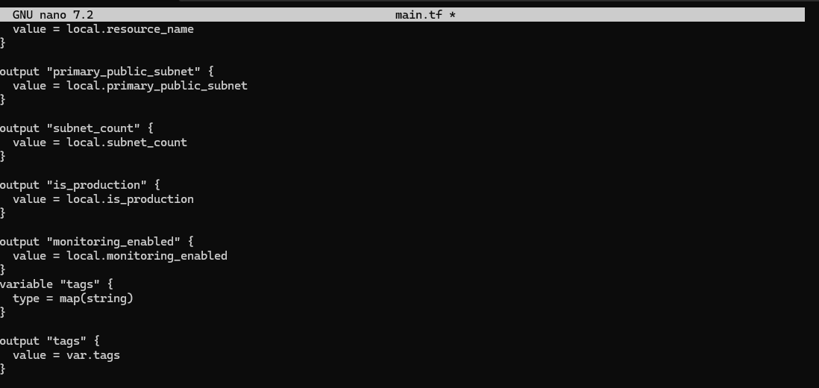
- In terraform.tfvars:
tags = {
Environment = "dev"
Project = "sample-app"
Owner = "platform-team"
}
Run:
terraform apply -auto-approve
# check tags output
- Save screenshot as: task4_tags_output.png — apply output showing tags returned.
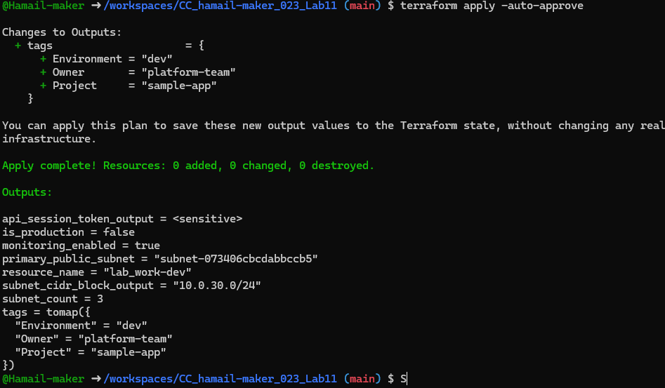
- Define object variable:
variable "server_config" {
type = object({
name = string
instance_type = string
monitoring = bool
storage_gb = number
backup_enabled = bool
})
}

output "server_config" {
value = var.server_config
}
In terraform.tfvars:
server_config = {
name = "web-server"
instance_type = "t3.micro"
monitoring = true
storage_gb = 20
backup_enabled = false
}
- Save screenshot as: task4_server_config_output.png — apply output showing server_config object.

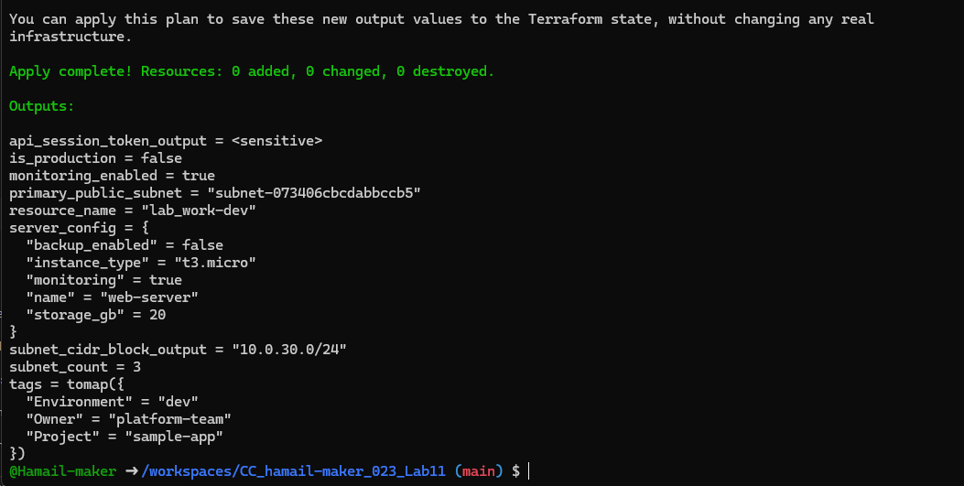

Task 5 — Collections: list, tuple, set & mutation via locals
In this task you will define collection variables (list, tuple, set), observe their behavior, then perform mutations via locals and compare results.
Feature | List | Tuple | Set
Order preserved | ✅ | ✅ | ❌
Allows duplicates | ✅ | ✅ | ❌
Mixed types | ❌ | ✅ | ❌
Fixed size | ❌ | ✅ | ❌
Mutable | ✅ | ❌ | ✅
Best for | Flexible sequences | Structured records | Unique collections
- In main.tf define:
variable "server_names" {
type = list(string)
default = ["web-2", "web-1", "web-2"]
}

variable "server_metadata" {
type = tuple([string, number, bool])
default = ["web-1", 4, true]
}

variable "availability_zones" {
type = set(string)
default = ["me-central-1b", "me-central-1a", "me-central-1b"]
}

output "compare_collections" {
value = {
list_example = var.server_names
tuple_example = var.server_metadata
set_example = var.availability_zones
}
}
- Save screenshot as: task5_collections_defined.png — main.tf showing collection variables and output.
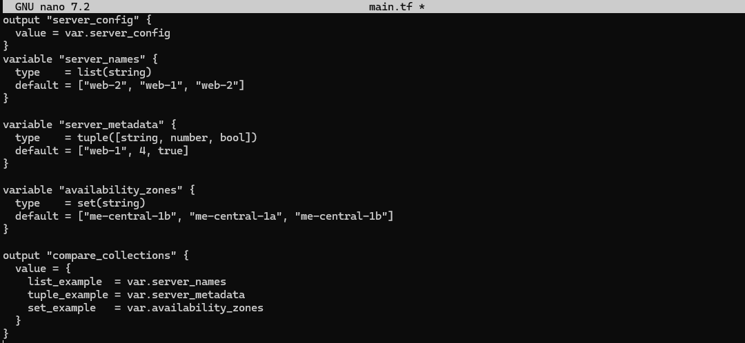
- Run:
terraform apply -auto-approve
Observe the output — note ordering, duplicates, and that sets are displayed without duplicates and order is not guaranteed.
- Save screenshot as: task5_compare_collections.png — apply output comparing of collections.
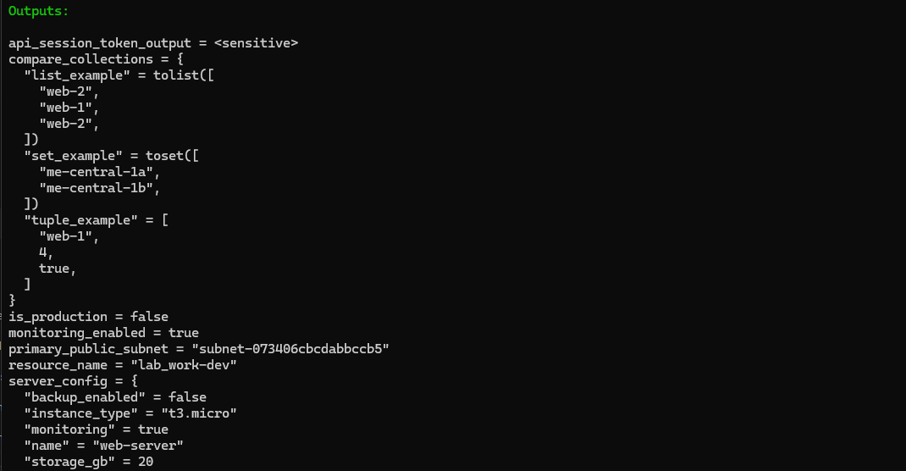
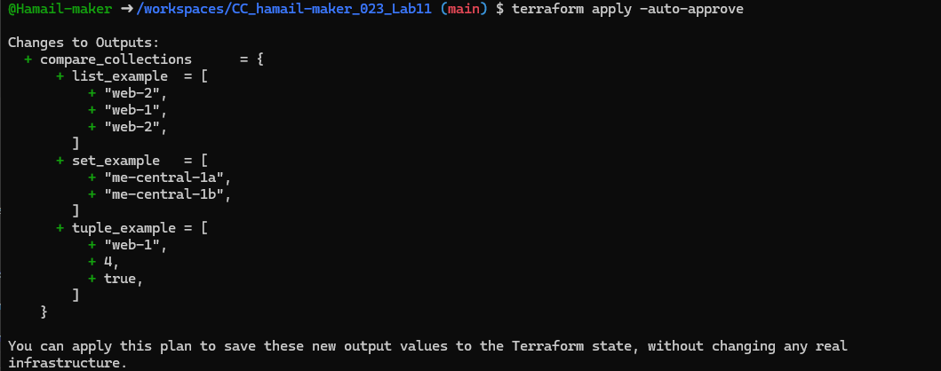
- In locals.tf add mutations: Create or edit locals.tf and add the following locals to demonstrate mutation behavior. Note: tuples are immutable in Terraform's type system, but many operations convert them to lists for evaluation.
locals {
mutated_list = setunion(var.server_names, ["web-3"])
mutated_tuple = setunion(var.server_metadata, ["web-2"])
mutated_set = setunion(var.availability_zones, ["me-central-1c"])
}
- Save screenshot as: task5_locals_mutations.png — locals.tf showing mutated values.
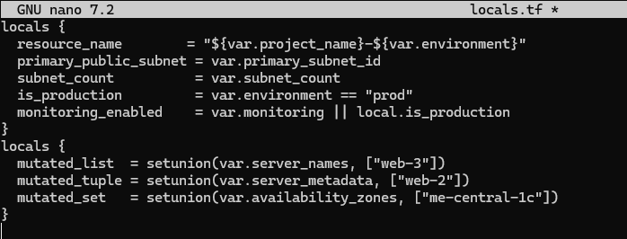
- Add comparison output in main.tf:
output "mutation_comparison" {
value = {
original_tuple = var.server_metadata
mutated_tuple = local.mutated_tuple
}
}
Run:
terraform apply -auto-approve
Observe the difference between the original tuple and the mutated result. Note that Terraform may represent the mutated tuple as a list and the ordering/duplicates behavior will reflect setunion semantics.
- Save screenshot as: task5_mutation_comparison.png — apply output comparing original and mutated tuple.
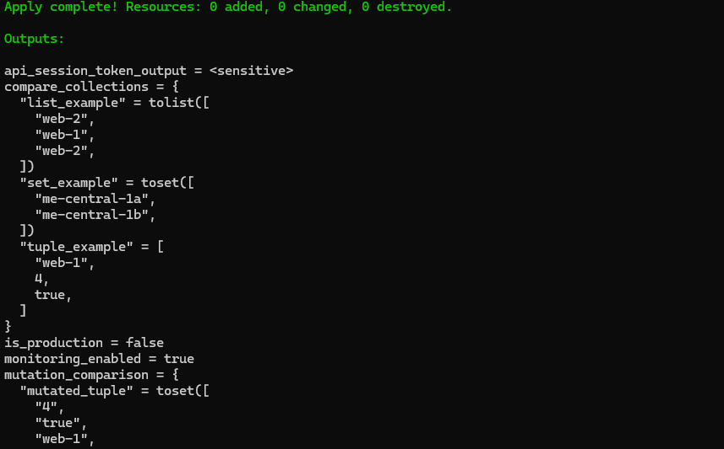
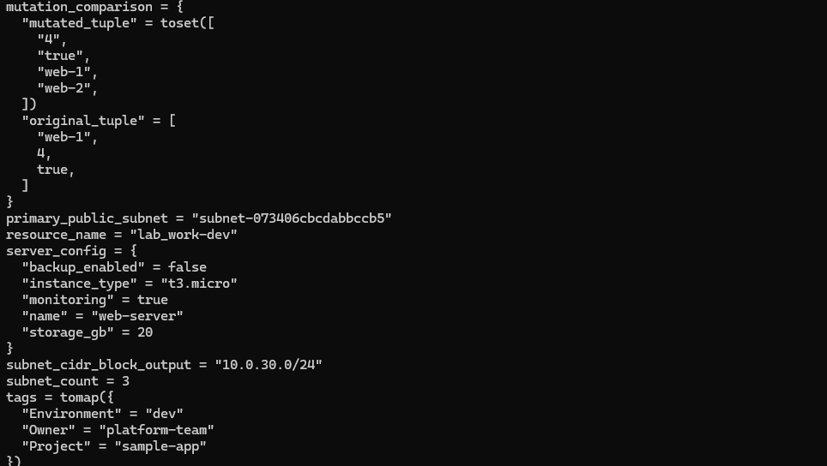

Task 6 — Null, any type & dynamic values
- Null variable:
variable "optional_tag" {
type = string
description = "A tag that may or may not be provided"
default = null
}
- Save screenshot as: task6_optional_tag_variable.png — main.tf showing optional_tag variable.
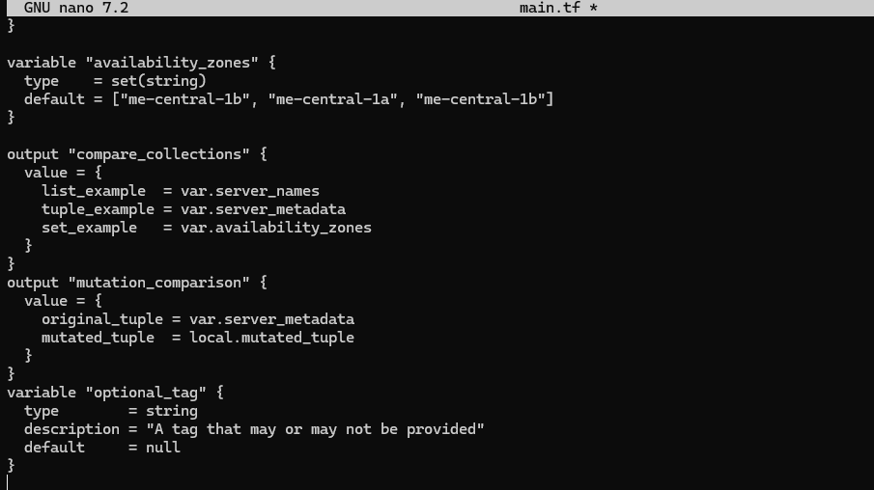
- Merge tags in locals.tf:
locals {
server_tags = merge(
{ Name = "web-server" },
var.optional_tag != null ? { Custom = var.optional_tag } : {}
)
}
- Save screenshot as: task6_locals_merge.png — locals.tf showing merge logic.
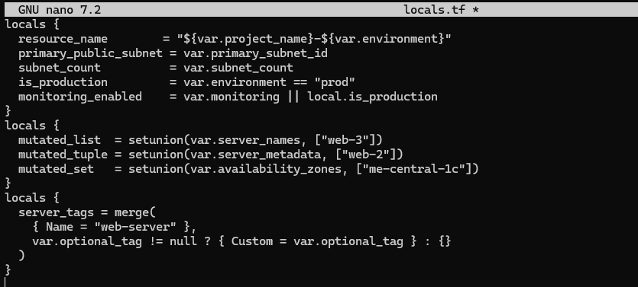
- Output:
output "optional_tag" {
value = local.server_tags
}
Run:
terraform apply -auto-approve
- Save screenshot as: task6_optional_tag_no_value.png — apply output with no optional_tag
set.
- Add in terraform.tfvars:
optional_tag = "dev"
terraform apply -auto-approve
# observe that Custom tag appears
- Save screenshot as: task6_optional_tag_with_value.png — apply output after setting
optional_tag in terraform.tfvars.
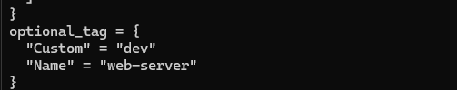
- Any type variable:
variable "dynamic_value" {
type = any
description = "A variable that can accept any data type"
default = null
}

output "value_received" {
value = var.dynamic_value
}
- Now test the dynamic (any) variable with different types. For each change, update terraform.tfvars with the specified value and run terraform apply -auto-approve, then capture the output.
a) String
- In terraform.tfvars:
dynamic_value = "hello"
- Run:
terraform apply -auto-approve
- Save screenshot as: task6_dynamic_value_string.png — apply output when dynamic_value = "hello".
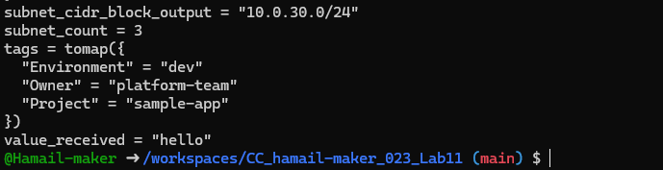
b) Number
- Change terraform.tfvars:
dynamic_value = 42
- Run:
terraform apply -auto-approve
- Save screenshot as: task6_dynamic_value_number.png — apply output when dynamic_value = 42.
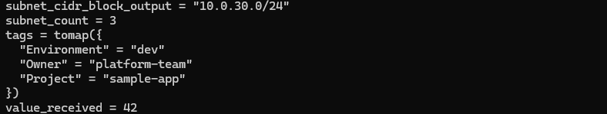
c) List
- Change terraform.tfvars:
dynamic_value = ["a", "b", "c"]
- Run:
terraform apply -auto-approve
- Save screenshot as: task6_dynamic_value_list.png — apply output when dynamic_value is a list.
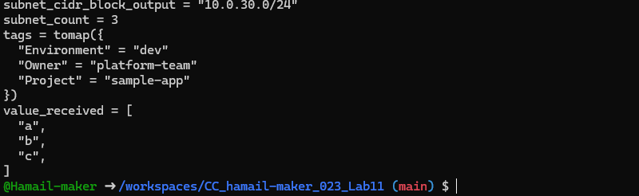
d) Map / Object
- Change terraform.tfvars:
dynamic_value = {
name = "server"
cpu = 4
}
- Run:
terraform apply -auto-approve
- Save screenshot as: task6_dynamic_value_map.png — apply output when dynamic_value is a map/object.
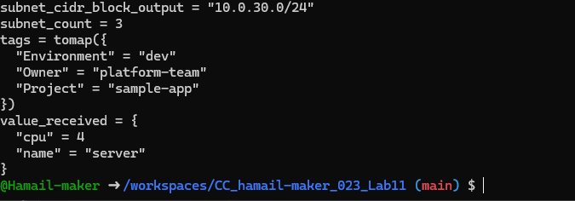
e) Null
- Change terraform.tfvars:
dynamic_value = null
- Run:
terraform apply -auto-approve
- Save screenshot as: task6_dynamic_value_null.png — apply output when dynamic_value = null.
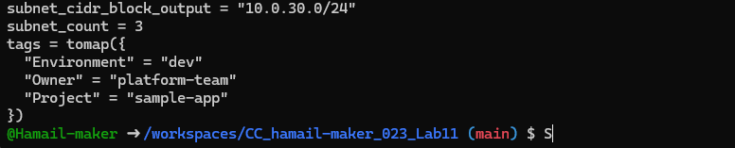

Task 7 — Git ignore
Create .gitignore:
touch .gitignore
Add entries:
.terraform/*
*.tfstate
*.tfstate.*
*.tfvars
*.pem
- Save screenshot as: task7_gitignore_created.png — .gitignore file content showing entries.
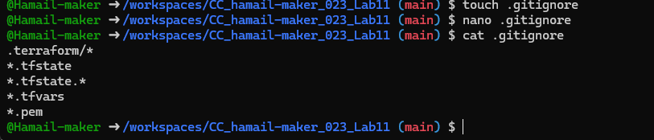

Task 8 — Clean-up then build real infra (VPC, Subnet, IGW, routing, default route table)
In this task you will clean previous example values and build a simple VPC + Subnet, attach an Internet Gateway, and configure routing (first with a custom route table and association, then switch to the default route table).
Perform all commands inside your Codespace shell.
- Clean previous files
- Remove all variable assignments from terraform.tfvars (empty the file or delete it).
- Remove all content from locals.tf (delete or empty the file).
- Replace main.tf contents with only the provider block below (start fresh).
Provider block to put in main.tf:
provider "aws" {
shared_config_files = ["~/.aws/config"]
shared_credentials_files = ["~/.aws/credentials"]
}
- Save screenshot as: task8_clean_files.png — showing cleaned terraform.tfvars, locals.tf, and main.tf.
- Define variables in main.tf Add these variable declarations to main.tf (below the provider block):
variable "vpc_cidr_block" {}
variable "subnet_cidr_block" {}
variable "availability_zone" {}
variable "env_prefix" {}
- Save screenshot as: task8_variables_recreated.png — main.tf showing the four variables added.
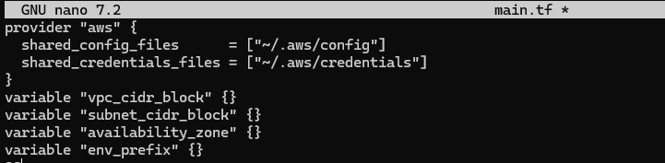
- Create VPC in main.tf Add the VPC resource to main.tf:
resource "aws_vpc" "myapp_vpc" {
cidr_block = var.vpc_cidr_block
tags = {
Name = "${var.env_prefix}-vpc"
}
}
- Save screenshot as: task8_vpc_resources_added.png — main.tf showing aws_vpc resource (after adding VPC).
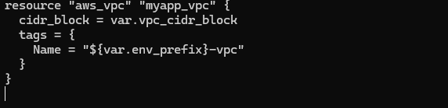
- Create Subnet in the VPC Add the subnet resource to main.tf:
resource "aws_subnet" "myapp_subnet_1" {
vpc_id = aws_vpc.myapp_vpc.id
cidr_block = var.subnet_cidr_block
availability_zone = var.availability_zone
tags = {
Name = "${var.env_prefix}-subnet-1"
}
}
- Save screenshot as: task8_subnet_resources_added.png — main.tf showing aws_subnet resource (after adding subnet).

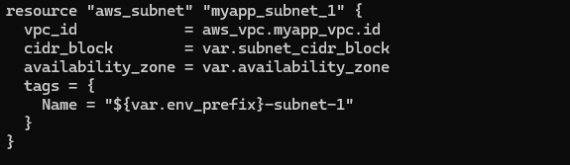
- Populate terraform.tfvars In terraform.tfvars add:
vpc_cidr_block = "10.0.0.0/16"
subnet_cidr_block = "10.0.10.0/24"
availability_zone = "me-central-1a"
env_prefix = "dev"
- Save screenshot as: task8_terraform_tfvars_vpc_values.png — terraform.tfvars content showing the values added.
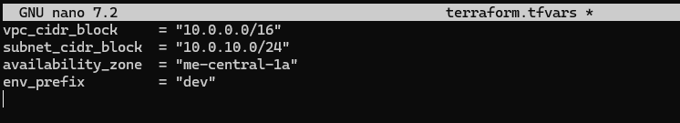
- Apply to create VPC and Subnet Initialize (if needed) and apply:
terraform init
terraform apply -auto-approve
Verify in AWS Console that the VPC and Subnet were created.
- Save screenshot as: task8_vpc_subnet_apply.png — terraform apply output showing VPC and subnet creation on AWS console screenshot.
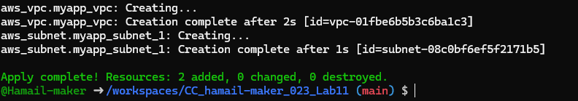
- Create Internet Gateway and Route Table (custom) Add the Internet Gateway and a custom Route Table to main.tf:
resource "aws_internet_gateway" "myapp_igw" {
vpc_id = aws_vpc.myapp_vpc.id
tags = {
Name = "${var.env_prefix}-igw"
}
}

resource "aws_route_table" "myapp_route_table" {
vpc_id = aws_vpc.myapp_vpc.id

route {
cidr_block = "0.0.0.0/0"
gateway_id = aws_internet_gateway.myapp_igw.id
}

tags = {
Name = "${var.env_prefix}-rt"
}
}
- Save screenshot as: task8_igw_route_table_before_apply.png — AWS console showing IGW and route table resources (before apply).
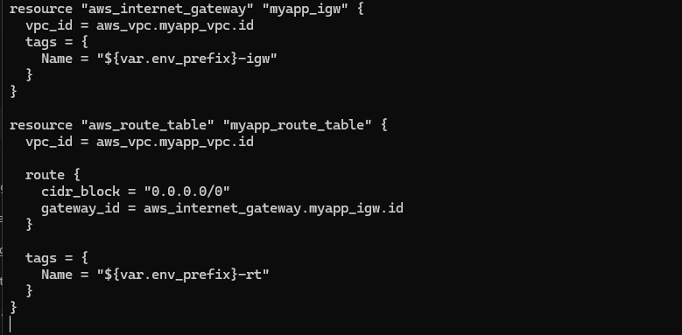
Apply:
terraform apply -auto-approve
Verify IGW and route table in AWS Console.
- Save screenshot as: task8_igw_route_table_after_apply.png — terraform apply output showing IGW and route table creation on AWS console.
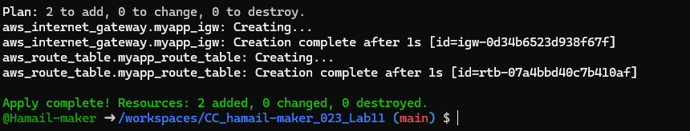
- Associate the Route Table with the Subnet Add the association resource to main.tf:
resource "aws_route_table_association" "a_rtb_subnet" {
subnet_id = aws_subnet.myapp_subnet_1.id
route_table_id = aws_route_table.myapp_route_table.id
}
Apply:
terraform apply -auto-approve
Verify association in AWS Console (Subnet → Route Table).
- Save screenshot as: task8_association_apply.png — terraform apply output showing association creation.
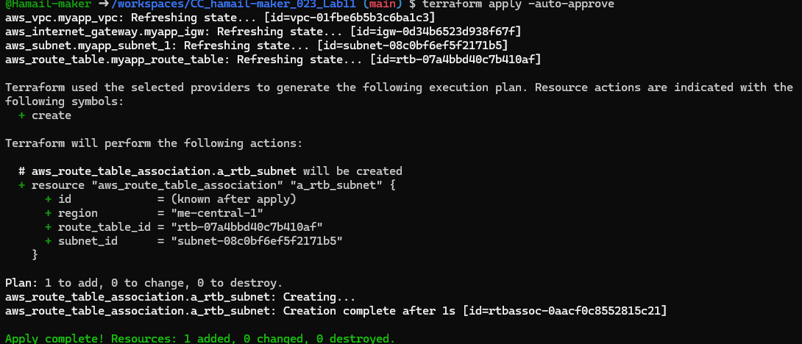
- Switch to default route table (use VPC default route table) Now remove (or comment out) the custom route table and association resources from main.tf:
- Remove the aws_route_table "myapp_route_table" block.
- Remove the aws_route_table_association "a_rtb_subnet" block.
Then add this resource to update the default route table with a route to the IGW:
resource "aws_default_route_table" "main_rt" {
default_route_table_id = aws_vpc.myapp_vpc.default_route_table_id

route {
cidr_block = "0.0.0.0/0"
gateway_id = aws_internet_gateway.myapp_igw.id
}

tags = {
Name = "${var.env_prefix}-rt"
}
}
- Save screenshot as: task8_default_route_table.png — main.tf showing aws_default_route_table resource (after change).
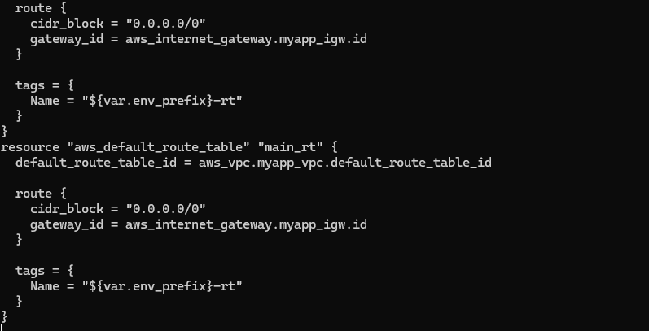
Apply:
terraform apply -auto-approve
Verify in AWS Console that the VPC's default route table has the 0.0.0.0/0 → IGW route and that the custom route table (if previously created) is no longer in use.
- Save screenshot as: task8_default_route_table_apply.png — terraform apply output showing default route table update.
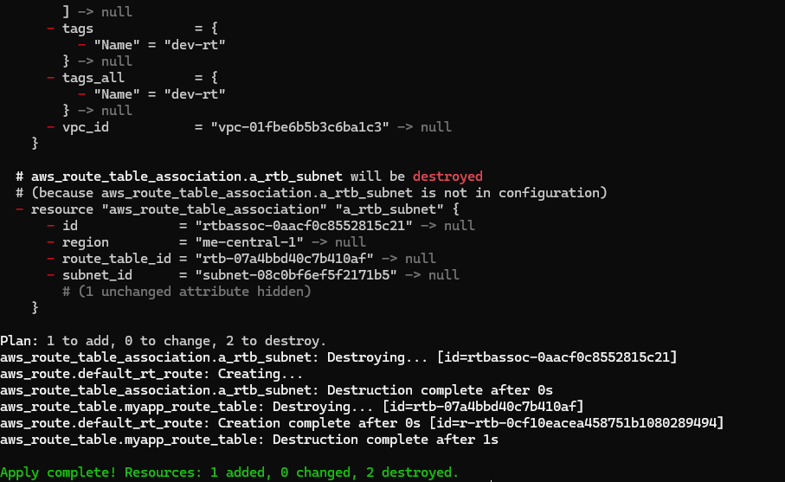

Task 9 — Security Group, Key Pair, EC2 Instance, user_data & nginx
This task walks you through creating a security group, creating an EC2 key pair, launching an EC2 instance, verifying SSH access, and installing nginx via user_data (inline and from a script). Perform all commands from your Codespace shell.
- Add variables to main.tf Add these variables to your main.tf:
variable "my_ip" {}
- Save screenshot as: task9_my_ip_variable_added.png — main.tf showing my_ip and other variables added.
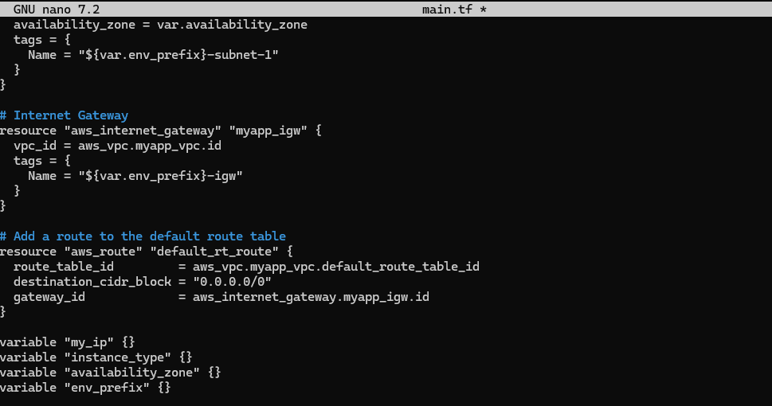
- Get your public IP and set terraform.tfvars From the Codespace shell:
curl icanhazip.com
Copy the IP and add to terraform.tfvars:
my_ip = "<your_ip>/32"
instance_type = "t3.micro"
availability_zone = "me-central-1a" # or your chosen AZ
env_prefix = "dev"
- Save screenshot as: task9_public_ip_curl.png — terminal showing curl icanhazip.com and terraform.tfvars edited with my_ip.
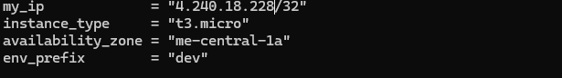
- Create the Security Group (main.tf) Add this resource to main.tf:
resource "aws_default_security_group" "myapp_sg" {
vpc_id = aws_vpc.myapp_vpc.id

ingress {
from_port = 22
to_port = 22
protocol = "tcp"
cidr_blocks = [var.my_ip]
}

ingress {
from_port = 80
to_port = 80
protocol = "tcp"
cidr_blocks = ["0.0.0.0/0"]
}

egress {
from_port = 0
to_port = 0
protocol = "-1"
cidr_blocks = ["0.0.0.0/0"]
prefix_list_ids = []
}

tags = {
Name = "${var.env_prefix}-sg"
}
}
- Save screenshot as: task9_security_group_apply.png — main.tf showing security group resource (before apply).
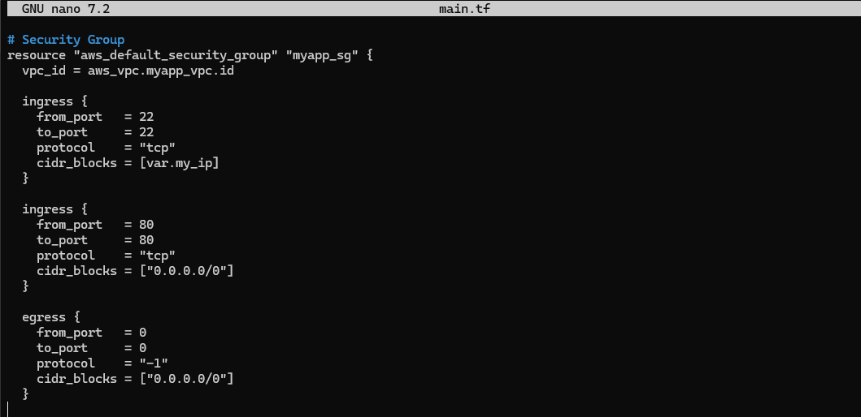
Run apply:
terraform apply -auto-approve
- Save screenshot as: task9_security_group_apply.png — terminal showing terraform apply output for security group (after apply) and verify in AWS Console.
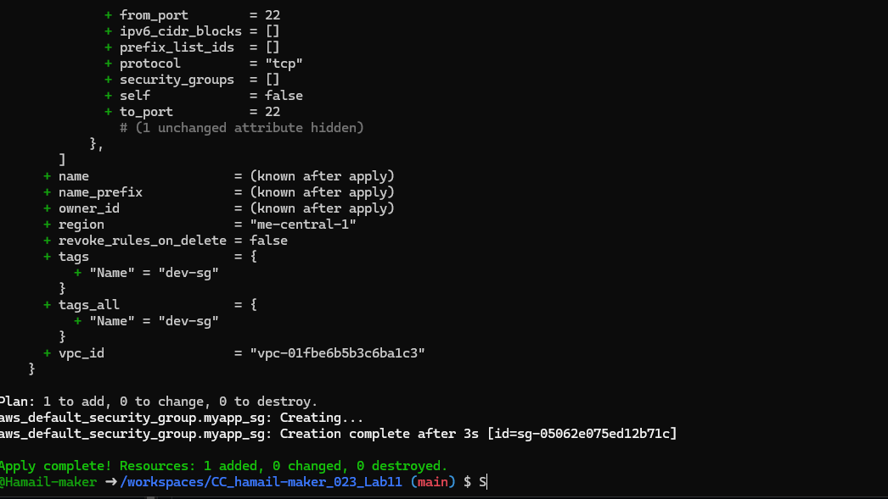
- Create an AWS key pair and save locally Create a key pair and store the private key in your Codespace. Do NOT commit the .pem file.
aws ec2 create-key-pair \
--key-name MyED25519Key \
--key-type ed25519 \
--key-format pem \
--query 'KeyMaterial' \
--output text > MyED25519Key.pem

chmod 600 MyED25519Key.pem
- Save screenshot as: task9_keypair_created_and_saved.png — terminal showing key creation and MyED25519Key.pem saved.
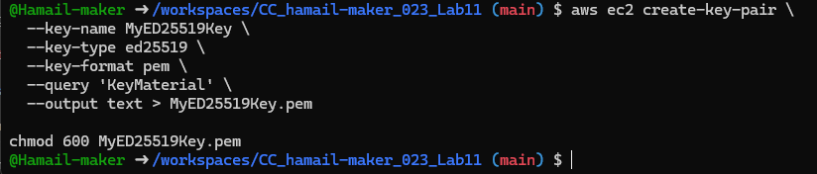
Ensure .gitignore contains:
*.pem
- Save screenshot as: task9_keypair_created_and_saved.png — .gitignore showing *.pem entry.

- Add EC2 instance resource (initial) Add the instance resource to main.tf (initially using the created key name):
resource "aws_instance" "myapp-server" {
ami = "ami-05524d6658fcf35b6" # Amazon Linux 2023
instance_type = var.instance_type
subnet_id = aws_subnet.myapp_subnet_1.id
security_groups = [aws_default_security_group.default_sg.id]
availability_zone = var.availability_zone
associate_public_ip_address = true
key_name = "MyED25519Key"

tags = {
Name = "${var.env_prefix}-ec2-instance"
}
}

output "aws_instance_public_ip" {
value = aws_instance.myapp-server.public_ip
}
- Save screenshot as: task9_instance_type_set.png — main.tf showing instance_type variable and aws_instance resource (before apply).
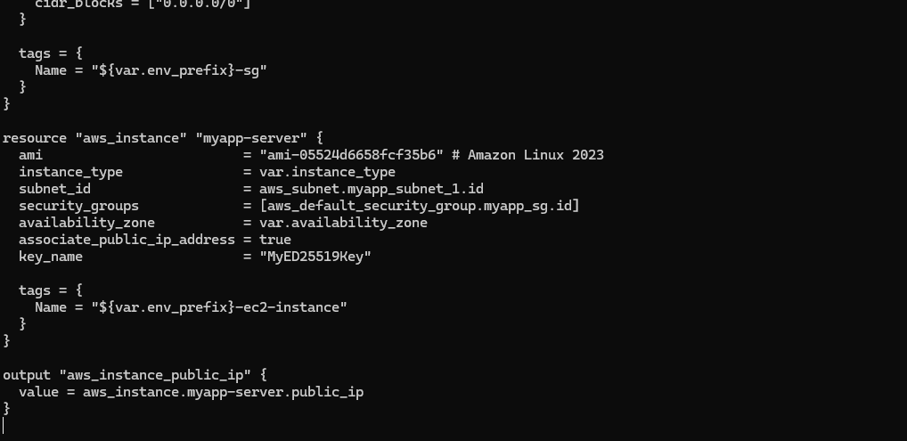
Run:
terraform apply -auto-approve
- Save screenshot as: task9_ec2_apply_and_public_ip.png — terraform apply output showing EC2 created and public IP (or terraform output).
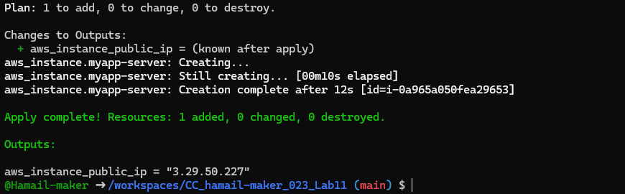
- SSH into the instance (using MyED25519Key) From the Codespace:
ssh -i MyED25519Key.pem ec2-user@<public-ip>
# verify commands, then exit
exit
- Save screenshot as: task9_ssh_into_ec2.png — terminal showing successful SSH session using MyED25519Key.pem.
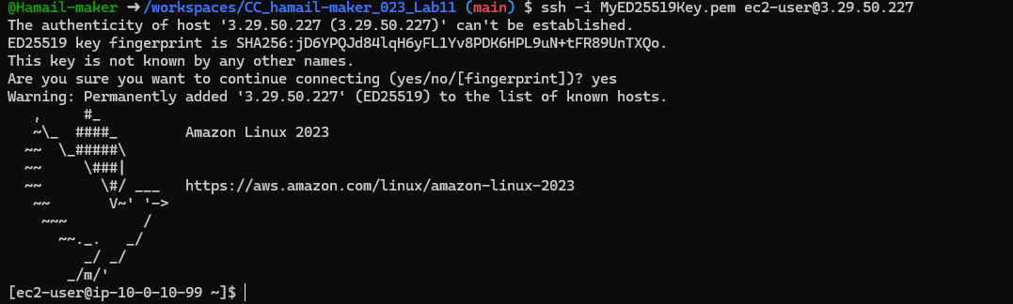
- Generate a local SSH keypair and register it in AWS via Terraform On your Codespace, generate an SSH key pair (accept defaults or specify path):
ssh-keygen -t ed25519 -f ~/.ssh/id_ed25519 -N ""
- Save screenshot as: task9_ssh_keypair_and_ssh.png — terminal showing ssh-keygen output and files in ~/.ssh.
Add a Terraform resource in main.tf to register the public key:
resource "aws_key_pair" "ssh_key" {
key_name = "serverkey"
public_key = file("~/.ssh/id_ed25519.pub")
}
Update the EC2 resource to use the Terraform-managed key:
resource "aws_instance" "myapp-server" {
...
# replace key_name = "MyED25519Key" with:
key_name = aws_key_pair.ssh_key.key_name
...
}
- Save screenshot as: task9_ssh_keypair_and_ssh.png — main.tf showing aws_key_pair resource and updated aws_instance key_name.
Run:
terraform apply -auto-approve
- Save screenshot as: task9_ec2_apply_and_public_ip.png — terraform apply output showing EC2 updated to use new key (and any changes).
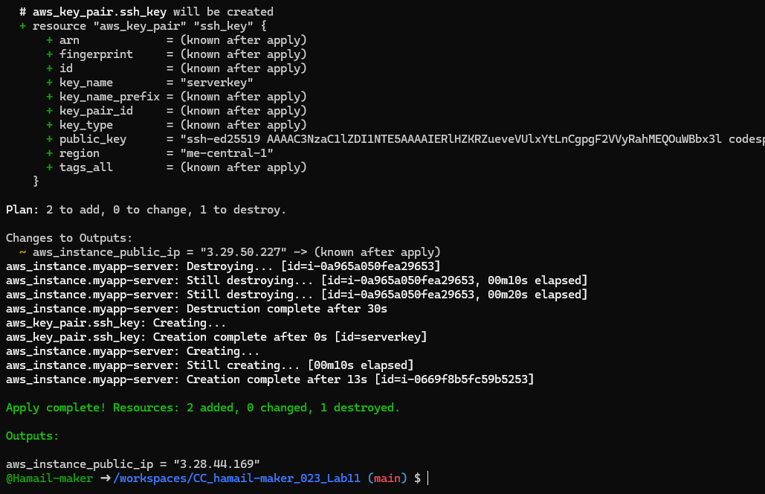
- SSH using the newly registered key Now SSH with your generated private key (the default ssh client will pick up ~/.ssh/id_ed25519):
ssh ec2-user@<public-ip>
Verify login works.
- Save screenshot as: task9_ssh_keypair_and_ssh.png — terminal showing SSH session using the generated key.
- Install nginx via inline user_data Modify the aws_instance resource to include inline user_data:
resource "aws_instance" "myapp-server" {
...
user_data = <<-EOF
#!/bin/bash
yum update -y
yum install -y nginx
systemctl start nginx
systemctl enable nginx
EOF
tags = {
Name = "${var.env_prefix}-ec2-instance"
}
}
Apply:
terraform apply -auto-approve
SSH in and run:
curl localhost
Open http://<public-ip> in a browser — you should see the nginx default page.
- Save screenshot as: task9_nginx_local_curl.png — curl localhost inside the EC2 instance showing nginx response.
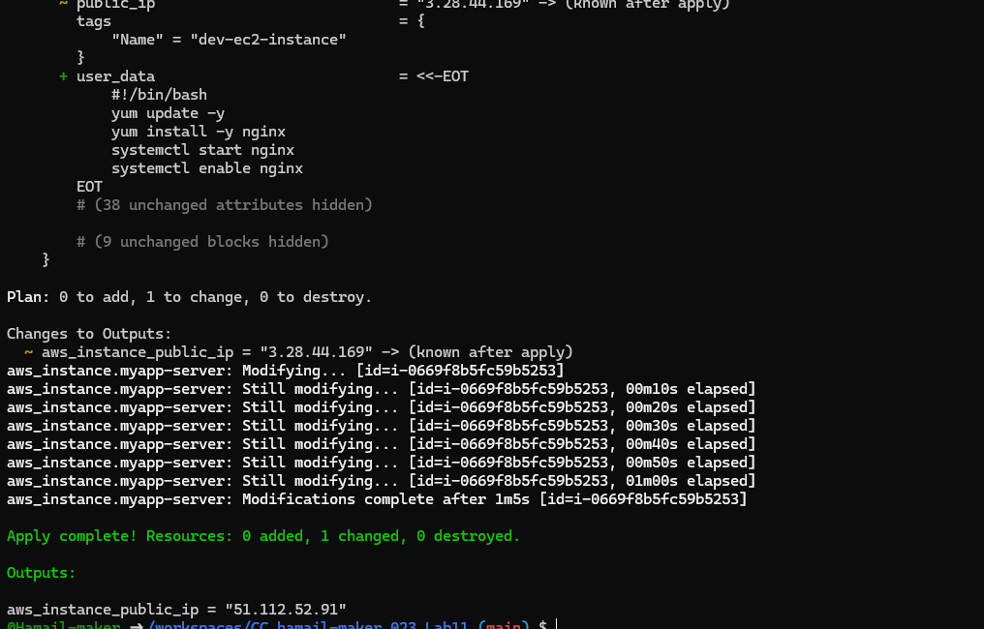
- Save screenshot as: task9_nginx_browser_page.png — browser showing nginx default page at http://.
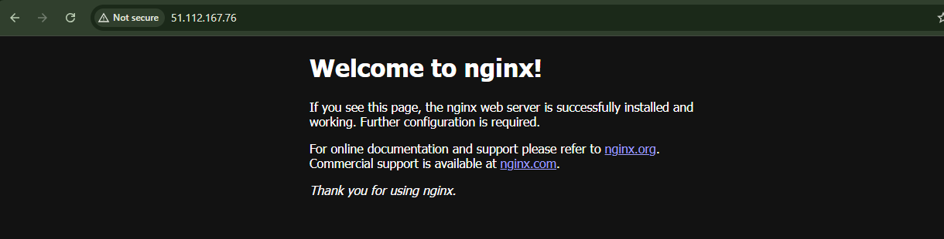
- Use an external script for user_data Create a script file in the Codespace:
cat > entry-script.sh <<'EOF'
#!/bin/bash
yum update -y
yum install -y nginx
systemctl start nginx
systemctl enable nginx
EOF
- Save screenshot as: task9_nginx_local_curl.png — entry-script.sh created and permissions set.

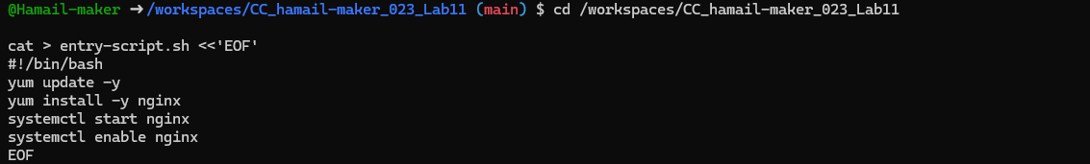
Update aws_instance to use the file:
resource "aws_instance" "myapp-server" {
...
user_data = file("entry-script.sh")
tags = {
Name = "${var.env_prefix}-ec2-instance"
}
}
Apply:
terraform apply -auto-approve
Reload the browser at http://<public-ip> to confirm nginx is served.
- Save screenshot as: task9_nginx_browser_page.png — browser showing nginx page after using entry-script.sh.
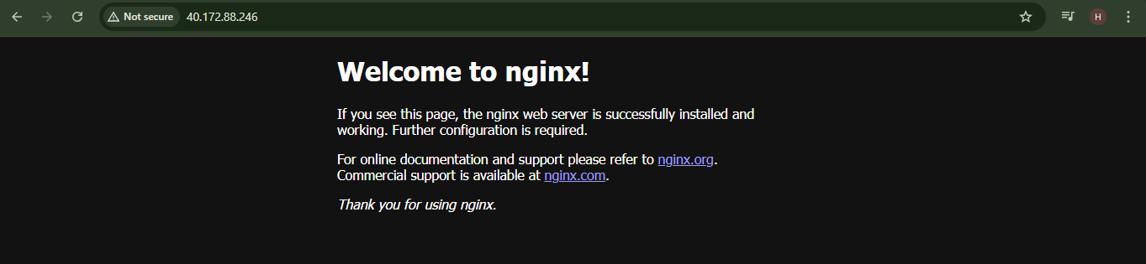

Cleanup
- Destroy all resources:
terraform destroy -auto-approve
- Save screenshot as: cleanup_destroy.png — terraform destroy output showing resources deleted.
- Verify state files:
cat terraform.tfstate
cat terraform.tfstate.backup
- Save screenshot as: cleanup_state_files.png — showing terraform.tfstate and terraform.tfstate.backup contents (ensure no secrets are exposed).
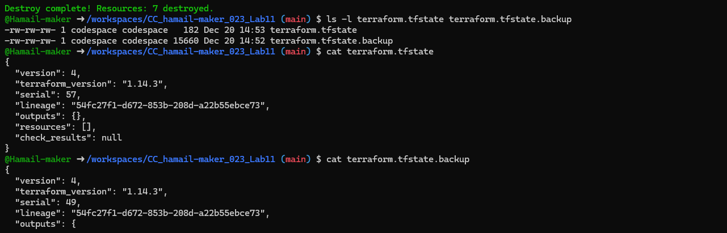
- Ensure no sensitive files are committed. If any private keys or credentials were accidentally committed — rotate them immediately.
- Save screenshot as: cleanup_verify_no_secrets.png — git status and .gitignore confirming no .pem, .tfstate, or credentials are staged.
